1 Circle the correct answer. (10 points)
1. We ..... geography on Thursday.
a. has got b. haven’t got c. hasn’t got
2. ..... Jane got new friends?
a. Has b. Is c. Have
3. ..... a computer in your classroom?
a. There is b. Are there c. Is there
4. ..... pupils in front of the school.
a. There aren’t b. There is c. Are there
5. Have you got a notebook? Yes, I ..... .
a. am b. haven’t c. have
6. Have we got English ..... Monday?
a. at b. in c. on

2 Write a sentence for each picture. Use There is / There are and the words below. (10 points)
on  between in front of next to under behind
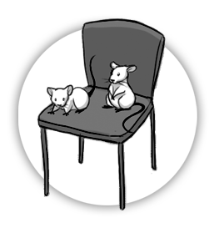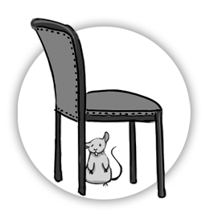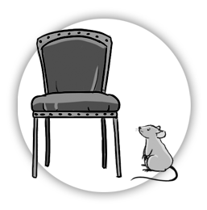
There are two mice on the chair.
1. ..........................................................................
1
2
3
2. ..........................................................................
3. ..........................................................................
4. ..........................................................................
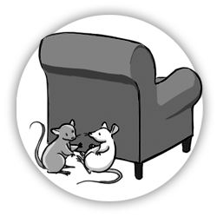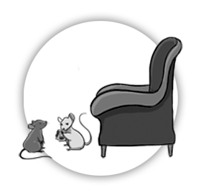
4
5
6
5. ..........................................................................
6. ..........................................................................

3 Circle the correct answer. (6 points)
1. I’ve got a new dog. The dog’s / dogs’ name is Blackie.
2. My mothers / mother’s eyes are blue.
3. The pupils have got a nice teacher. The pupil’s / pupils’ teacher is Miss Green.
4. We have got a computer. Our / Your computer is new.
5. Have you got a TV in her / your room?
6. The children are at their / its grandmother’s house today.
4 Circle the correct answer. (12 points)
1. Do / Does your cat drink water?
Yes. He love / loves water.
2. When / What do you meet friends?
We meet / meets on Tuesdays in the afternoon.
3. Do your mum and dad work / works in the afternoon?
No, they don’t / doesn’t.
4. When / Where do you live?
I live / lives near the school.
5. Does / Do Brad get up at 7 o’clock?
Yes, he does / do.
6. Who / Why does Pete walk to school?
He walk / walks to school because it’s near his house.
5 Write sentences with the words below. (5 points)
1. drink / I / every morning / milk
……………………………………………………………………………………………………………………..
2. the children / play / sometimes / in the park / football
……………………………………………………………………………………………………………………..
3. to school / never / Tom / walks
……………………………………………………………………………………………………………………..
4. swims / at the swimming pool / my mum / often
……………………………………………………………………………………………………………………..
5. always / my friends and I / computer games / play
……………………………………………………………………………………………………………………..

6 Complete. Use Present Simple. (10 points)
works
1. Sam ......................................... (work) at the weekends.
2. My friends and I ......................................... (do) our homework after school.
3. My friend ......................................... (not go) to the swimming pool on Sundays.
4. The children ......................................... (not watch) TV in the morning.
5. Danny ......................................... (play) football every day.
6. Joanne ......................................... (not walk) to school.

7 Write questions with DO - DOES. Then answer them about yourself. (6 points)
1. you / go to school / on Saturday
Do you go to school on Saturday?
No, I don’t.
.............................................
2. you and your friend / walk to school / every morning
.............................................
3. you / drink milk / every day
.............................................
4. your friend / sit in front of you / at school
.............................................

8 Circle the correct answer. (6 points)
1. That dog needs water. Please give it / them some.
2. The president lives there. We can’t visit you / him.
3. Sarah is my friend. I speak to me / her every day.
4. Harry and I need help. Please help us / them.
5. It’s cold! Let’s / Don’t open the window.
6. Let’s / Don’t play in the park. We can have fun.
9a Write can / can’t. (4 points)
1. Snakes ......................................... walk. 3. Children .......................................... study at school.
2. Fish ............................................. swim. 4. Elephants ............................................. climb trees.
9b Write questions with can. Then answer them. (6 points)
Can zebras play basketball?
No, they can’t.
1. zebras / play basketball ................................................... .........................................
2. dogs / throw balls ................................................... .........................................
3. cats / climb trees ................................................... .........................................
4. fish / swim ................................................... .........................................
10 Complete. Use Present Continuous. (8 points)
1. Jill ......is reading........ (read) a book at the moment. She ....isn’t watching........... (not watch) TV.
2. The girls ................................... (ride) bikes in the park. They ................................... (not climb) trees.
3. I ..................................... (not do) my homework now. I ..................................... (go) to visit my cousin.
4. My parents ....................................... (not sleep). They ...................................... (cook) supper for me.
5. Amy ......................................... (sit) right now. She ......................................... (not stand).

